[1]

Quadruped robot with brushless motors

R. Le Corronc, M. Kulbicki

*Abstract*—In this work, we attempt to develop an autonomous quadruped robot with brushless motors experimentally. We use standard brushless motors, so we have designed and produced our own motor reducer to increase the output torque and reduce the speed. An onboard AI is used to compute the quadruped robot’s trajectory and avoid obstacles. This AI is packed on a Nvidia Jetson Nano and is launched under Docker containers.

A study for the PID loop used for the legs is lead and simulations are run to effectively determinate the correct correctional coefficient.

*Index: Robotic; quadruped motion robot; brushless motor powered; motor reducer; autonomous robot; Nvidia Jetson Nano.*

# INTRODUCTION

T

HE privacy and security of private warehouses is a delicate mission which must be ensured 24 hours a day. The issue being that the operators in charge of this task are subject to fatigue, inattention or corruption. The use of an autonomous robot able to assist these operators could also increase the surveillance time slot. The quadruped robot we have conceived mimics the dog’s physiology due to the large versatility of motion offered by such a model. Most importantly, this model can achieve stairs climbing, allowing it to freely move in buildings. On the market, quadruped robots are animated using two types of motors: brushless motors [1] or servomotors [2]. The speed and power consumption offered by the standard brushless motors lead us to create our robot using this motor. Brushless motors deliver high rotation speed for low current consumption. The downside of brushless motors resides in the its low torque. Hence, our main challenge was centered around designing a motor reducer compact enough to be included in our robot. Moreover, we wish to make this project fully open-source and have made a GitHub [3] containing all details about this project.

# Mechanical structure

## Designing and production

The production of the robot is subject to certain constraints. In particular due to the machines we have access to. We work with a FabLab, so we have access to 3D printers and a laser cutter which is perfect for an opensource project. We limit ourselves in terms of materials, to plastic, plexiglass, and wood. The metal work is very complicated. Each part has been designed so that they can be printed in 3D or cut on a 2D plan.

## Body

A general quadruped robot is built on a vessel combining lightness and sturdiness []. The first model we conceived for the quadruped robot’s body is simple and takes the shape of an opened cube. Having flat surfaces facilitates the production, hence the prototyping of the vessel. Moreover, the center of mass is approximately the same as the geometrical center, easing simulations and computation around the general motion of the robot.

The vessel is the support to two carbon fiber tubes, acting as the shoulders for the legs of the robot. Their circular shape ensures high resistance to compression and their carbon fiber nature highly increases its folding endurance. Wood and plexiglass are respectively the material used for prototyping and rendering the vessel.

## Legs

According to the existing prototypes and the dog robots already on the market, there are mainly 2 leg structures, the so-called diamond legs [], and the legs copying the biological structure of the dog []. We have chosen to use the second option, because in view of its layout, this structure is the simplest to cross the steps of a stair. The leg has 3 joints. The knee and the hip, allowing to move the tip of the leg at each place on a 2D plane. Then the shoulder, allowing to tilt the whole paw and thus to give a third dimension to the paw movement.

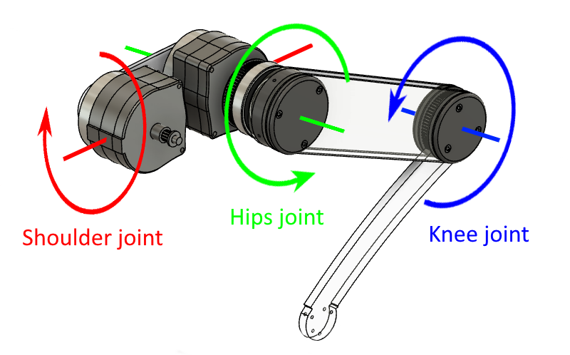

Figure 1. The three joints of the robot leg and their axes. The shoulder, the hip and the knee. The leg is composed of two main parts in plexiglass and the rest is in PETG. There are two compact motor reducers at the shoulder to control the knee joint and the hip joint.

The paws are the elements most subject to shocks and degradations. We therefore wanted parts that were simple to make and above all easy and quick to replace. Due to its speed of execution, we decided to make them with a laser cut. Three choices were offered to us in terms of materials, wood, plexiglass and carbon fiber. The wood being too fragile and the carbon fiber too expensive, we chose the plexiglass for the right balance that this material offers us, resistance, lightness, and cost. The articulations are made of steel for the highly solicited parts, like the bearings or the rods used as axis. The rest of the parts are printed in PETG.

The dimensioning of the legs depends on one element, the complexity of the ground on which the robot evolves. Here, the robot will be on a building floor, a totally flat floor. Its only constraint will be to be able to climb stairs. So, the legs have been designed to climb standard stairs. The standard steps are on average 17cm high. Leaving us a margin of flexibility, we decided to use legs with a maximum height of 30cm. This will allow the robot to adapt in case it meets higher steps.

## Hardware

The quadruped robot autonomous trajectory and behavior is driven by the Nvidia Jetson Nano TX []. This compact computer can run image regression deep neural-network models enabling it to infer X-Y coordinates for specific objects in images collected by the C505e Logitech Camera []. It also uses serial communication to collect data from the Arduino Uno board. This last one is responsible for the computation of the raw data returned by the distinct sensors aboard the quadruped vessel. For instance, a GY-521 sensor is controlled by an Arduino I2C bus and retrieves the robot’s yaw/pitch/roll and real acceleration (gravity acceleration omitted).

A SlamTec RP Lidar is built up on the upper face of the vessel, preventing self-carried components from interfering with its acquisition task.

An HC-SR04 (ultra-sound sensor) is mounted on the front of the body. Its data is collected through numerical pins and used by the Uno to estimate distance to jeopardies.

Two servo-driven carrycots disposed fore of the vessel allow the HC-521 and C505e to cover wide angle (up to 170° panel) and direction independent from the quadruped robot’s body.

Finally, the complete project is powered using two 4s 50C 5000mAh Li-Po batteries for a total over-estimated use of half an hour.

# Motorization

The big difficulty was to incorporate the brushless motors. We chose 360kv brushless motors. These motors having little torque and high speed, about 5,300rpm for 6.25mN.m. So we had to dimension motor reductors.

We determined that 1/50 reducers were necessary to recover the most torque and to be able to move the leg at 4π rad/s. The reducer is composed of two epicyclic gears in series, then a pulley-belt reducer.

Without knowing the displacement of this type of motor, we will add potentiometers on the output axes of the reducers. This will allow us to know precisely, without shift and at each moment, the angle of each joint. We can then finish the servo control of the motors.

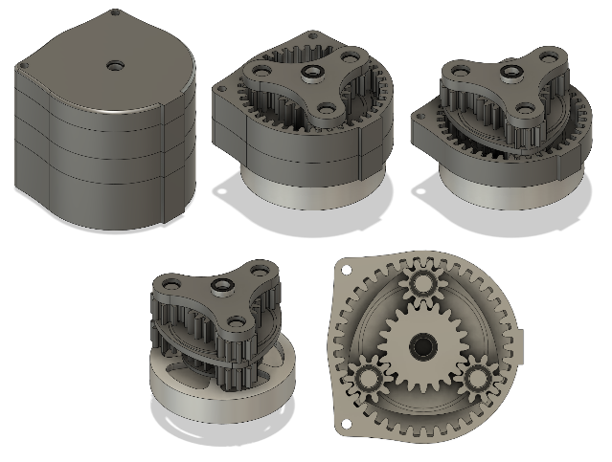

Figure 2. The motor reducer. It is composed of two epicycloidal gearboxes in series. It is connected directly to the brushless motor to be as compact as possible.

# Movement control study

The brushless motors are the actuators responsible for the rotation of the joints in the robot’s legs. These motors are driven by an electronic speed controller (ESC) which acts on the motor’s speed. Potentiometers are disposed on every axis to feedback the position variations. However, for practical use, each leg is represented in its own Cartesian coordinate system where the configuration of the leg is given by the coordinates of its foot.

Thus, this study seeks to achieve the precise configuration of a leg allowing its foot to merge with the entered desired position. One section of this study is focused on the determination of the angles allowing to achieve the requested position, whilst another section is centered around the control of the position feedback of each joint.

## Inverse kinetic problem

The leg of the robot can be represented in a Cartesian coordinate system (xyz) in which two plans are enough to describe the entire leg configuration. The lower leg can be described in a (xOz) plane, whereas the shoulder is set in a (zOy) plane. As shown on the figures 3 and 4, the leg’s configuration is represented by the position of its foot’s coordinate (Mx,My,Mz), or the OC vector.

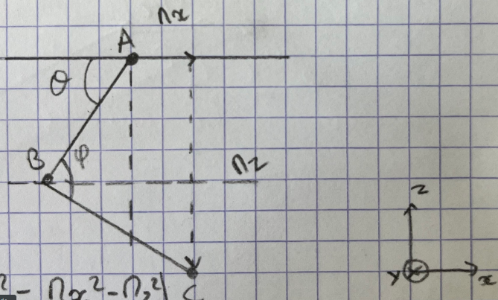

Figure 3. The representation of the lower leg and upper leg in a (zOx) plane.

A is the hip axis. B is the knee axis. C is the foot.

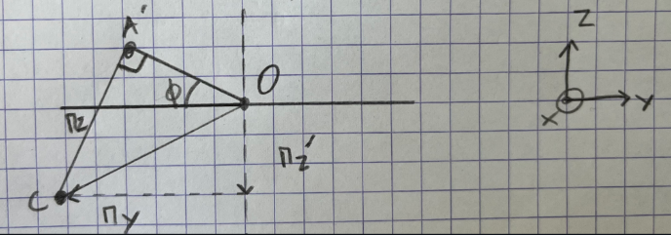

Figure 4. The representation of the shoulder’s inclination in a (z0y) plane. O is the intersection between the shoulder’s revolution axis and the hip’s axis. A’ is the projection of A onto the (zOy) plane. Mz’ is the height of the leg for a given configuration.

Using basic trigonometry relations and mainly Al Kashi’s theorem [6], we can expose the useful relations between the different unknows (ϑ,φ,ψ,Mx,My,Mz’).





Figure 5. The relations used to compute the angles for each joints when a leg configuration is requested. The second formula for ϑ is used when the given Mx value is negative.

The lengths AB, BC and OA’ are known as the real length of the robot’s leg.

The relations shown in figure 5 involve mainly trigonometry relations which require low computation power.

## Servo-control system

This study seeks to adapt the motor’s speed in a way that it can approach a given angle smoothly (without rebounds). The potentiometers on each joint provide feedback and allow to precisely approach the desired angle.

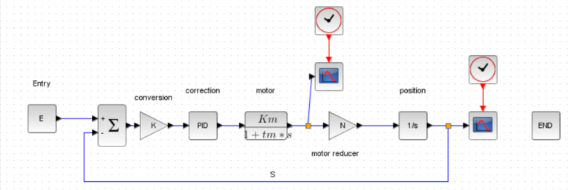

Figure 6. This is a representation of each joint’s correctionnal angle system.

The parameters used in the representation of this system are: E is the entry of the system (rad); K converts an angle into a command for the ESC; Km is the motor’s static gain; Tm is the motor’s mechanical time constant and N is the motor-reduction coefficient.

In this representation of the system, we start by removing the output angle S from the desired input E. The resulting angle is converted by K into a rotation speed for the ESC. The ESC order is corrected by the PID block. The motor is represented by a simple first order system since the electrical time constant Te is negligible in front of the mechanical time constant Tm. In our case, our motor’s transfer function is realized by the time constant Tm and a static gain Km. The speed is then reduced by the motor-reducer. The following block integrates the output speed, allowing to retrieve the position of the motor-reducer’s axis. From there, we plug the output angle in the differentiator, subtracting the output from the input.

Due to the lack of datasheet on the motors, we are not able to lead a proper PID study. Details on the moment of inertia or the resistive torque of the motor are needed for a precise PID study. Therefore, the Ziegler Nichols method [7] is appropriate for our project.

Furthermore, since our system presents an integration block (Figure 6. The block 1/s), our system will not show any position mistake provided that our motors can rotate. This shortens our correctional study to the determination of the proportional (P) and derivative (D) constants.

# Conclusion

Simulation have been run to evaluate the quality of the robot conception and results are estimating the vessel over-designed (translating relative sturdiness) and the legs ready to be incorporated to the body.

The study of the correctional coefficients used to reach precisely and stably the desired position of the legs (PID) remains unachieved due to the lack of documentation around the brushless motors chosen. Simulations will be led once the basic motor characteristics (time mechanical constant and static gain) have been approximated through test runs.

The motor reducer designed and produced successfully increases the output torque of the brushless motors, allowing to freely move the quadruped’s legs.

References

1. R. Le Corronc, “Snoopytech” available at <https://github.com/RonanLc/Snoopytech>
2. <https://material-properties.org/fr/carbone-resistance-durete-elasticite-structure-cristalline/>
3. N. Kau, « StanfordDoggoProject » available at <https://github.com/Nate711/StanfordDoggoProject>
4. Boston Dynamics, SpotMini.product available at https://www.bostondynamics.com/products/spot/
5. Jetson Nano AI course available at <https://developer.nvidia.com/embedded/learn/jetson-ai-certification-programs#course_outline>
6. <https://fr.wikipedia.org/wiki/Loi_des_cosinus>
7. https://fr.wikipedia.org/wiki/M%C3%A9thode_de_Ziegler-Nichols

**Ronan Le Corronc**, received a university technological diploma in Electrical Engineering and Industrial Computing, in 2022, with the University Of Bordeaux, Bordeaux, France.

In the same time he received a university diploma in Robotic with the University Of Bordeaux, Bordeaux, France.

He is currently studying an engineering degree in Robotics and Autonomous System from the University of Cote d’Azur, Polytech Nice Sophia, Biot, France, since 2022.

**Maximilien Kulbicki** achieved the Polytech engineering schools course in 2022 at University Côte D’Azur, in Polytech Nice Sophia.

He is currently studying an engineering degree in Robotics and Autonomous System from the University of Cote d’Azur, Polytech Nice Sophia, Biot, France, since 2022.

1. Maximilien KULBICKI is with cote d’azur University, Polytech Nice Sophia, 930 route des Colles, 06410 Biot, France (e-mail: [maximilien.kulbicki@etu.unice.fr](mailto:maximilien.kulbicki@etu.unice.fr)).

   Ronan LE CORRONC is with cote d’azur University, Polytech Nice Sophia, 930 route des Colles, 06410 Biot, France (e-mail: [ronan.le-corronc@etu.unice.fr](mailto:ronan.le-corronc@etu.unice.fr)).